SEFTON PARK PALM HOUSE LIVERPOOL
ITG WHITE BADGE TRAINING COURSE

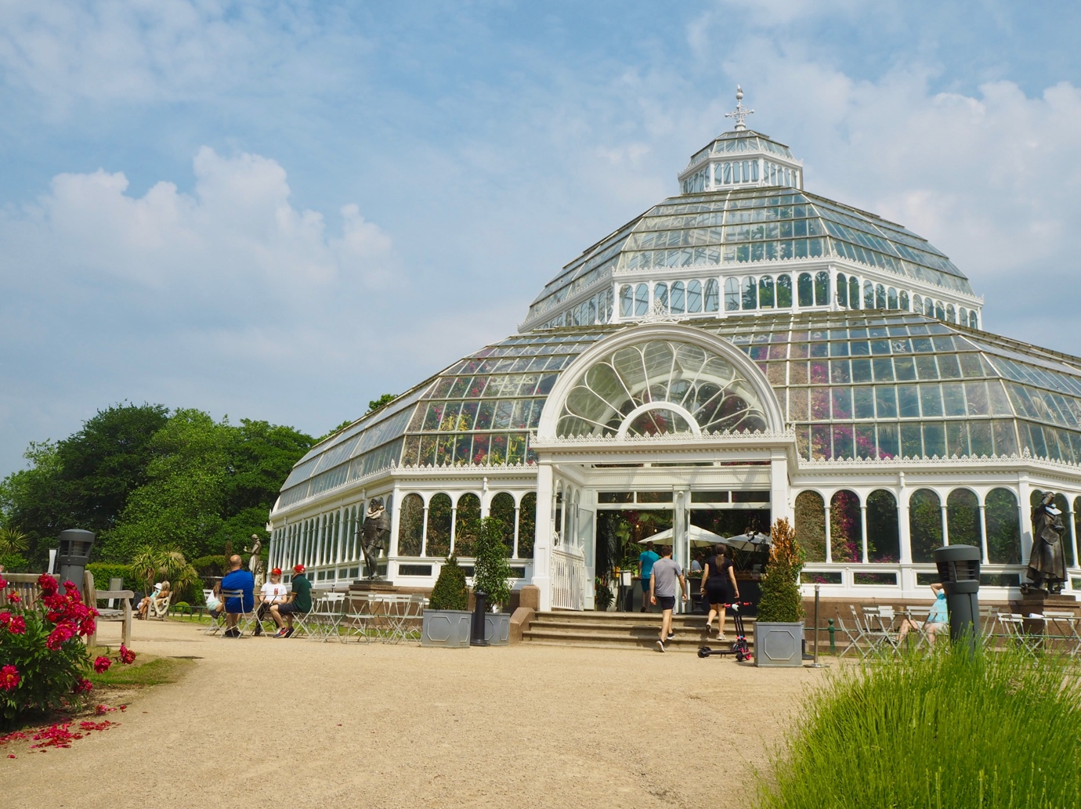

PROSPECTUS

Course Director:
Peter J. Colyer, BA(Hons), MEd, MA, PGCE, MITG
Institute of Tourist Guiding Guide Trainer

Course Provider:
Sefton Park Palm House Preservation Trust.

Accredited by the Institute of Tourist Guiding

Are you interested in being a well-informed volunteer guide at the Sefton Park Palm House? Then this course is for you!

Are you an ITG Blue or Green Badge Guide for the Liverpool City Region or Chester? Would you like to know more about this wonderful and historic building? Then this course is ideal CPD for you!

What is a Tourist Guide?
The role of a tourist guide is to accompany visitors to show them interesting places, explaining the significance of a site, its history and interesting stories connected with it, and so to enhance the visitor’s experience. But there is a great deal more to it than that. As well as being fully informed, the tourist guide is welcoming, enjoys working with people from many countries and backgrounds. Whilst with visitors, the guide also becomes a guardian and will alert visitors to safety issues, local customs, and engage in conversations. It is this rapport that develops between guide and visitor that makes the job so enjoyable.

Aims and Objectives of the course
The aim of the course is to provide a White Badge qualification for those wishing to welcome visitors to the Sefton Park Palm House, and to provide those visitors who wish to know more about the Palm House with information and a guided tour that meets their needs and expectations. Having passed the Institute of Tourist Guiding examinations, you will be qualified to offer flexible route tours on foot to groups and individuals inside the Palm House and within its grounds.
By the end of the course, you will have developed the skills to:
- Select a route for a site tour within the Palm House and its grounds which meets the requirements of groups and individuals. You will have an appreciation of any special needs, expectations and interests of the visitors and take into consideration their health and safety, comfort, and wellbeing;
- Present an effective commentary geared towards the target audience in terms of content, presentation, and duration. It will be clear, accurate, entertaining, and informative and the tour will include at least 10 appropriate stops;
- Deal with unexpected eventualities such as inclement weather, accidents and incidents during the tour and late arrivals.
- Demonstrate a range of communication skills.

COURSE SCHEDULE

All the training and the examinations will take place at the Palm House except for Day 3, the Communications Seminar when we will be at a meeting room in the Central Library on William Brown Street in the centre of Liverpool.

 | Day 1: Monday 25 September
9.00 | Registration & coffee/tea
9.30 | Introduction to the Palm House  - Health & Safety issues  - Operation strategy  - Funding | Kate Martinez, Head of External Relations. | 30 min
10. 00 | Outline of the course & examinations | Peter Colyer | 15 min
10.15 | The Context: Liverpool’s green spaces, botanical gardens, and The Ribbon of Parks. | Peter Colyer | 75 min
11.30 | Coffee/tea
12.00 | What is good site guiding? | Peter Colyer | 60 min
13.00 | Lunch: Please bring your own lunch, or you can buy lunch at the Palm House café.
14.00 | The building of Sefton Park | Stephen Lyus | 90 min
15.30 | Coffee/tea
16.00 | The Plants: talk & tour | Stephen Lyus | 90 min
17.30 | Finish
 | Day 2: Wednesday 27 September
9.00 | Registration & coffee/tea
9.30 | The History of the Palm House | Peter Colyer | 90 min
11.00 | Coffee/tea
11.30 | The Statues | Alex Cameron Robinson | 90 min
13.00 | Lunch: Please bring your own lunch, or you can buy lunch at the Palm House café.
14.00 | The Rebirth of the Palm House | Jane Baxter, Campaigner | 90 mins
15.30 | Coffee/tea
15.30 | Guiding practice | Peter Colyer | 90 mins
17.30 | Finish
 | Day 3: Friday 29 September
9 - 5 | Communications Seminar | Peter Colyer  Elizabeth Charnley | 8 hours
 | Day 4: Wednesday 4 October
9.00 | Registration & coffee/tea
9.30 | Guiding practice | Peter Colyer | 3 hrs 30
13.00 | Finish
 | Day 5: Monday 9 October
9.00 | Registration & coffee/tea
9.30 | Mock Written examination | Peter Colyer | 60 mins
10.30 | Coffee/tea
11.00 | Guiding Practice | Peter Colyer | 2 hours
13.00 | Finish
 | Day 6: Wednesday 11 October
9.00 | Registration. Coffee/tea
9.30 | Mock written examination feedback | Peter Colyer | 60 mins
10.30 | Guiding Practice | Peter Colyer | 2 hrs 30
13.00 | Finish
 | Day 7: Wednesday 1 November
 | Examination
 | Day 8: Thursday 2 November
 | Examination

APPLICATION AND SELECTION

Completed application forms should be sent be sent to Kate.Martinez@palmhouse.org.uk

- Interviews: Applicants will be asked to attend a short interview during which they will be asked to make a brief presentation of a site of their choice for no more than 3 minutes, without notes.
- Candidates offered a place on the course will be informed in writing following the interview.
- Candidates, of a minimum age of 18, will need to demonstrate an outgoing personality, smart appearance, good general knowledge, organisational ability, flexibility, a genuine interest in people, and an enthusiasm for the Sefton Park Palm House.

